**Task 01**

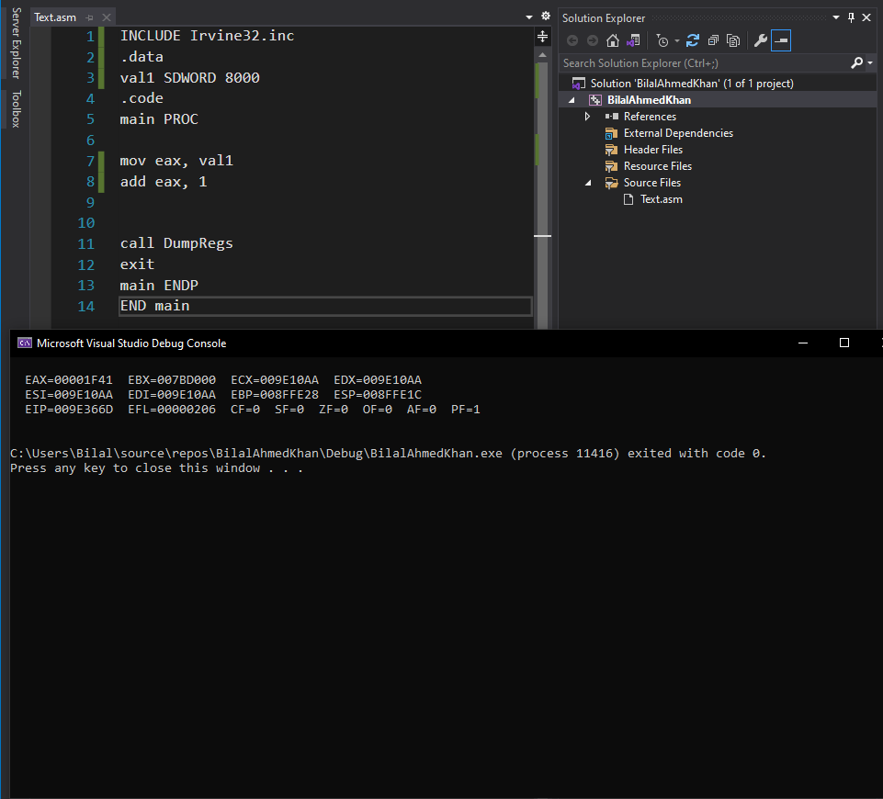

The value both Carry flag and sign flag are zero.

**TASK 02**

After first line

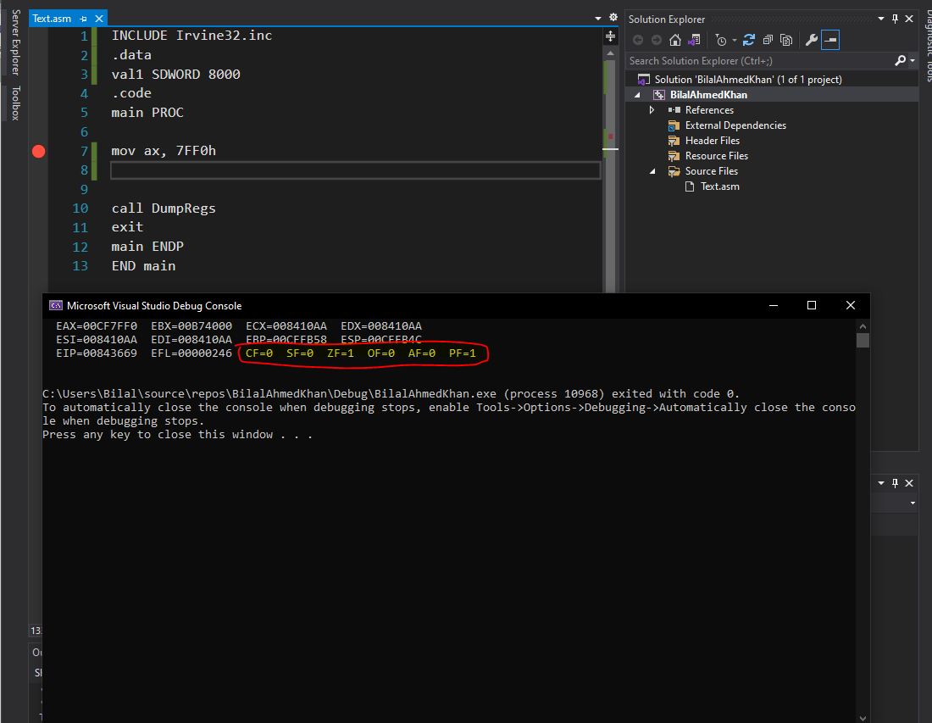

After second line

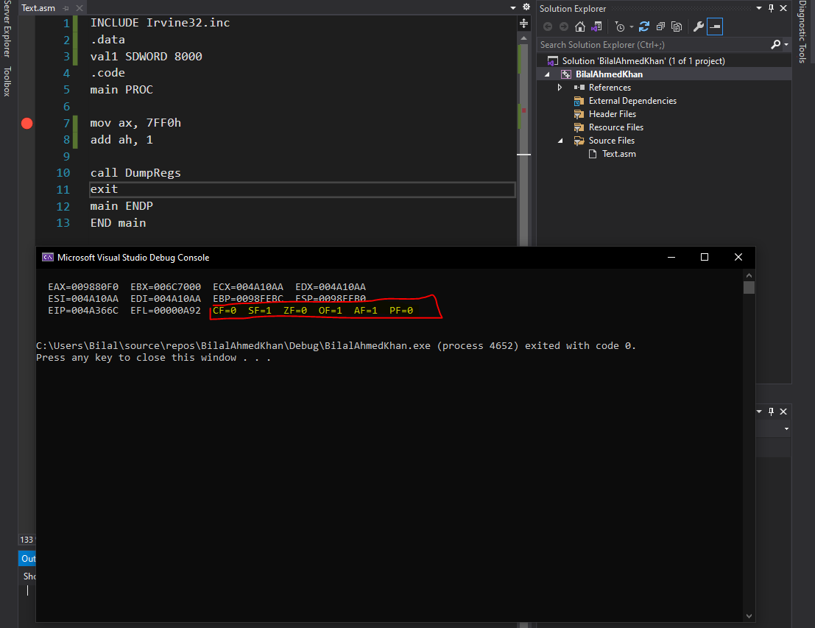

After third line

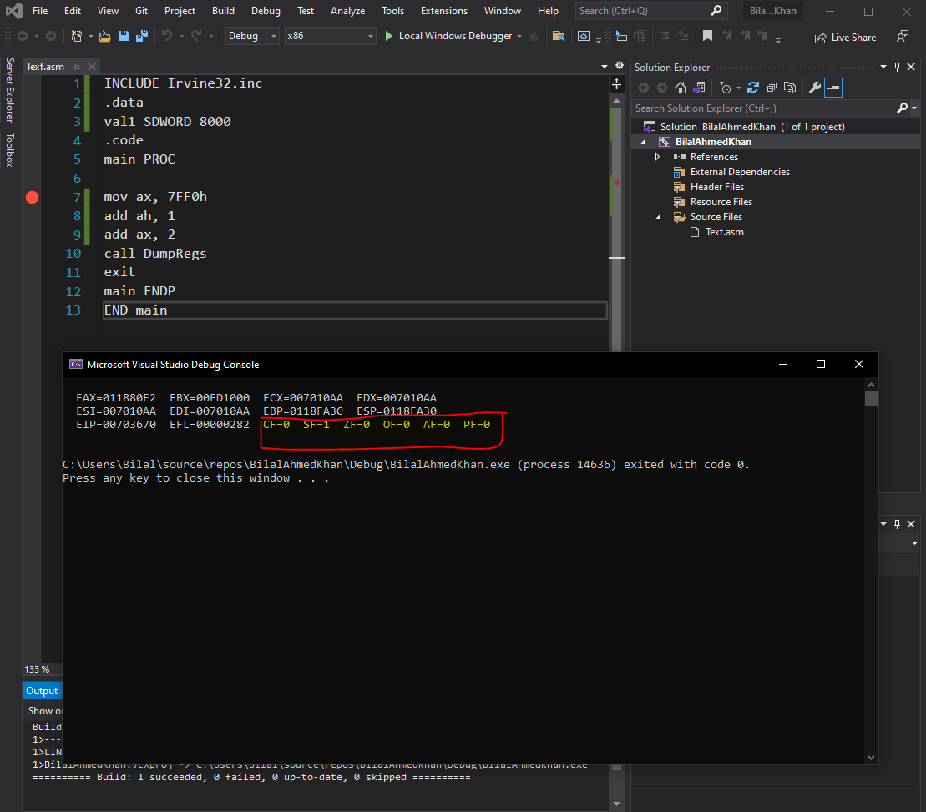

**TASK 03**

INCLUDE Irvine32.inc

.data

array DWORD 8,5,1,2,6

.code

main PROC

mov eax, 0

mov eax, [array+8]

mov ebx, [array+12]

mov ecx, [array+4]

mov edx, [array+16]

mov esi, [array+0]

call DumpRegs

exit

main ENDP

END main

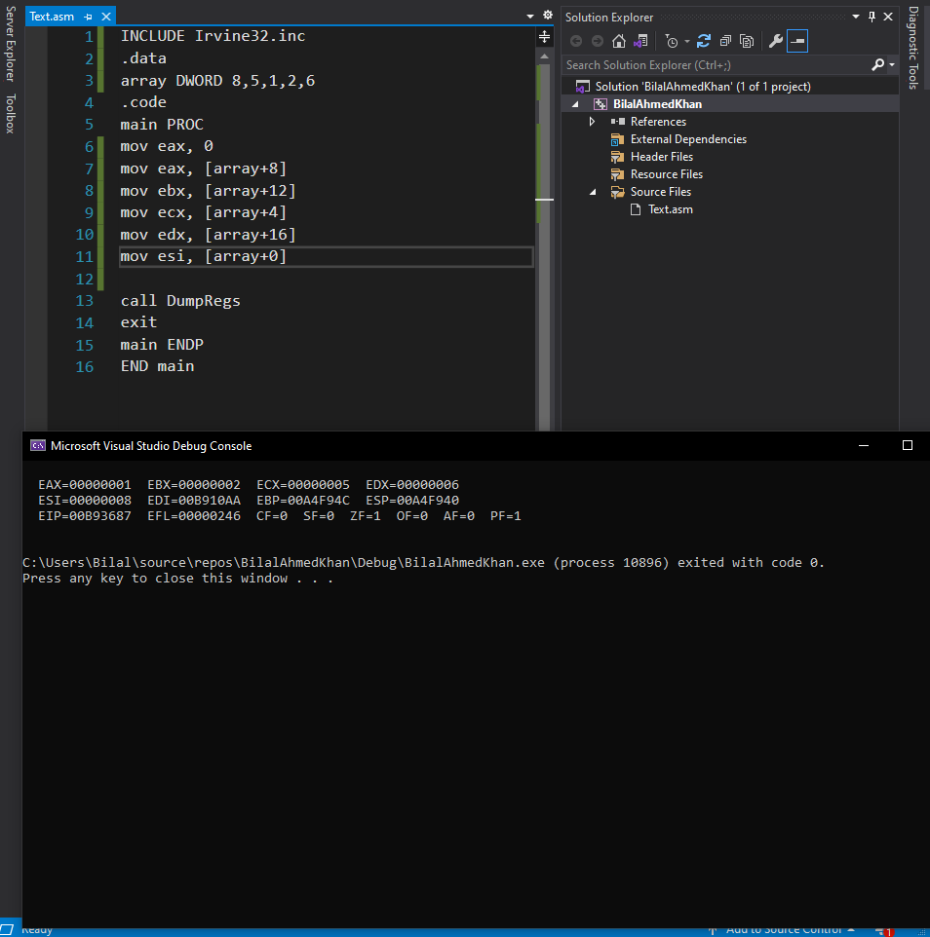

**TASK 04**

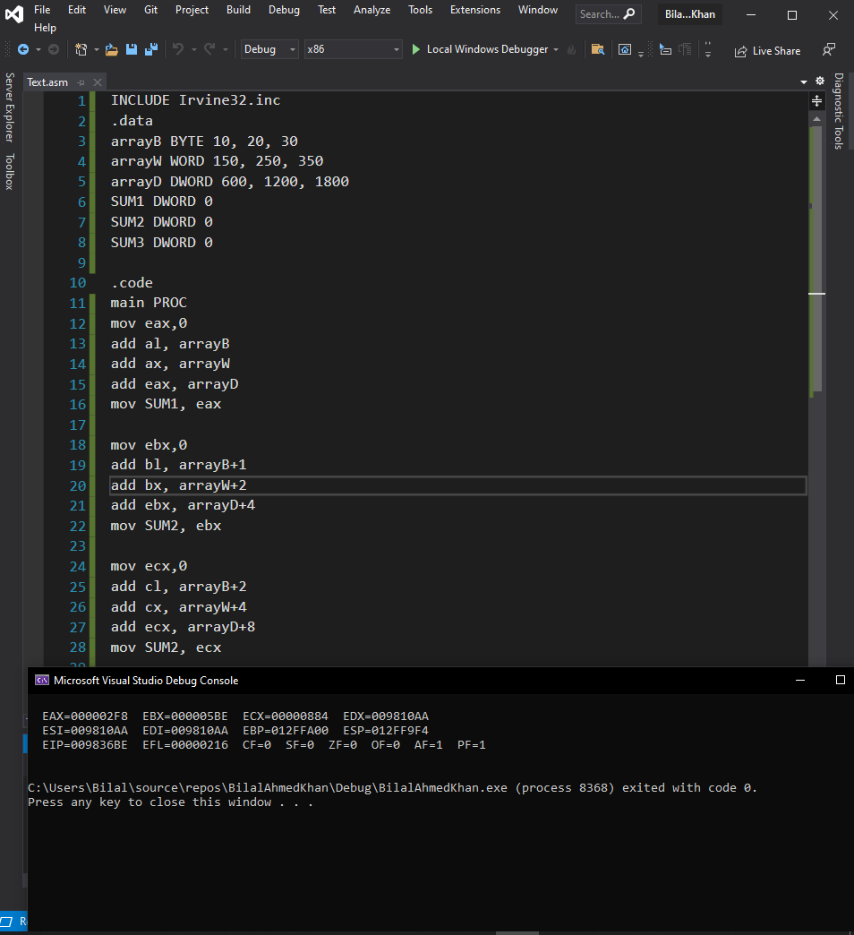

INCLUDE Irvine32.inc

.data

arrayB BYTE 10, 20, 30

arrayW WORD 150, 250, 350

arrayD DWORD 600, 1200, 1800

SUM1 DWORD 0

SUM2 DWORD 0

SUM3 DWORD 0

.code

main PROC

mov eax,0

add al, arrayB

add ax, arrayW

add eax, arrayD

mov SUM1, eax

mov ebx,0

add bl, arrayB+1

add bx, arrayW+2

add ebx, arrayD+4

mov SUM2, ebx

mov ecx,0

add cl, arrayB+2

add cx, arrayW+4

add ecx, arrayD+8

mov SUM2, ecx

call DumpRegs

exit

main ENDP

END main

**TASK 05**

INCLUDE Irvine32.inc

.data

array1 BYTE 10, 20, 30, 40

array2 BYTE 4 DUP (?)

.code

main PROC

mov eax, 0

mov ebx, 0

mov ecx, 0

mov edx, 0

mov al, array1

mov bl, array1+1

mov cl, array1+2

mov dl, array1+3

call DumpRegs

mov array2+0, dl

mov array2+1, cl

mov array2+2, bl

mov array2+3, al

mov al, array2+0

mov bl, array2+1

mov cl, array2+2

mov dl, array2+3

call DumpRegs

exit

main ENDP

END main

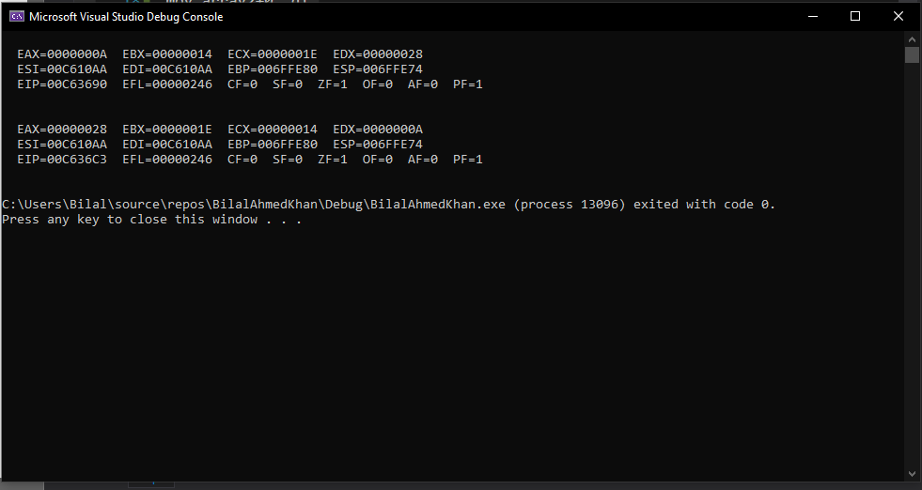

**TASK 06**

INCLUDE Irvine32.inc

.data

arrayB BYTE 60, 70, 80

arrayW WORD 150, 250, 350

arrayD DWORD 600, 1200, 1800

.code

main PROC

mov eax, 0

mov ebx,0

mov ecx,0

mov esi,0

mov al, arrayB[esi* Type arrayB]

mov esi, 2

add al, arrayB[esi* Type arrayB]

mov esi, 0

mov bx, arrayW[esi* Type arrayW]

mov esi, 2

add bx, arrayW[esi* Type arrayW]

mov esi, 0

mov ecx, arrayD[esi* Type arrayD]

mov esi, 2

add ecx, arrayD[esi* Type arrayD]

call DumpRegs

exit

main ENDP

END main

